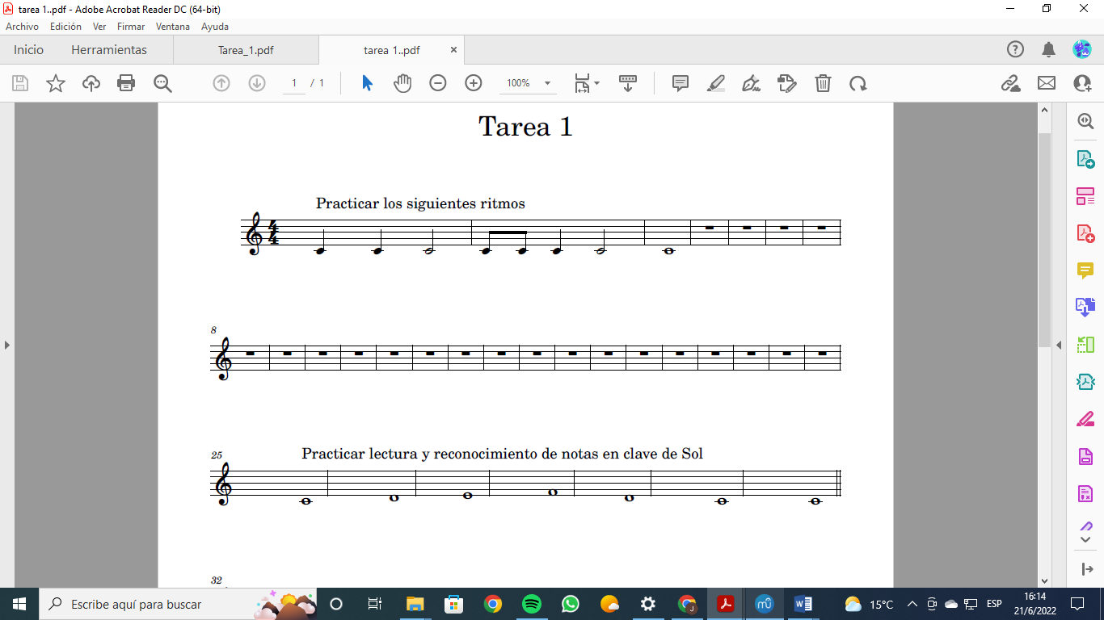

https://lh5.googleusercontent.com/F1iacaw1To6MqF17-cR-36fM6kIEPztHS4lSs8bH78d0K2kZTnfbtFGn11FFn-nGzieS0e4epJn3_G5j2yRttnGZs0DyIrkSkifRFRv8Wi2QctGbEkQa4-IBF5tHkOF7K2VRVLP4QKnB9vPieA

https://lh6.googleusercontent.com/w8DF5OgExFjEtBGcIFyoq4E26WKvcXUUl6Bb1F2iIkKPrMxYon96NjW-4la2T5hLQBh-xcxPwT9IvyN5AD9BcQPAWqYpUA47GtH2fo02PzyHeJnGGXXwcsB2il5hv-qElixbKTw3DRhBq3d-Xw

https://lh5.googleusercontent.com/Fg_C3m3hLy10ycZczJyRN3Wr-vHXhkgQsaNFO8YejrrUsNqoa8QOrhnmg8akeIMhl7EBxjiQMGnulTtYI_uiHzuJwbmyPwdvnBW65H_dl-3wroMAN5J928508kt5hJofMYgKPOmJE47QDSBLrA

https://lh3.googleusercontent.com/gYsAx1CL8f1qXKEOWCBp7qVeOp-_VaBsfi119TCAJkKlKX_oNphVZdgwiV4aQ_DruQPJ1aYLr0lwAQNtahrxtx5H5PondlS4t4SWmJHhmXO9sLxRtYLyd99XwoAx69atxLZX72csn2PcXlvE_Q

